**This is the use menu for JCmortga-mortgage calculator**

**(made by Junhao Chen) reserved all right.**

1. **Enter the total loan Amount into this field( the app will calculate the mortgage with the default interest rate of 6.5% and $0.0 downpayment).**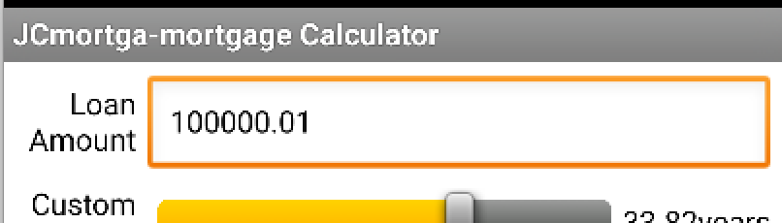
2. **Custom progressbar for adjusting fixable term(years) for the mortgage.**



1. **Default monthly display for 10,15,30 years.**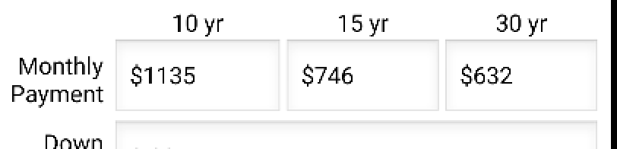
2. **Input for downpayment(default is $0.0), interest rate(default is 6.5%).**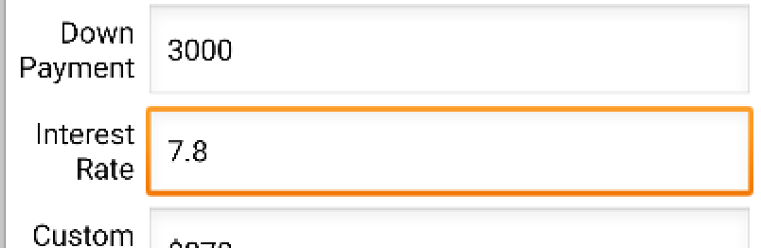
3. **Display window for various custom setting.**

